Appendix II

Extracts from

Selecting a Package
for
Graphics Presentation.

An Overview

Richard Bacon
Alex Nolan
Francis van Millingen

University of Edinburgh

Second Edition
First published October 1994

CONTENTS

3 Types of Chart (A Picture Gallery)
2D CHARTS
3.1 Scatter charts
3.2 Line charts
3.3 High-low charts
3.4 Bar/Column charts
3.5 Pie charts
3.6 Histograms
3.7 Area charts
3.8 Bubble charts
3.9 QC Charts
3.10 Polar charts
3.11 Cluster chart
3.12 Vector chart
3.13 Mixed charts
3.14 Organisation charts
3.15 Text charts
3.16 2D Contour charts
3D CHARTS
3.17 3D Scatter
3.18 3D Grid or regular column chart
3.19 3D Histogram
3.20 3D Surface charts
3.21 4D Contour charts
4 The Anatomy Of Charts and Drawings (The Picture Gallery extended)
Charts
Drawings
Aspects of Design
5 Using Graphics Files and Images
Popular file formats
BMP (Windows Bitmaps)
CGM (Computer Graphics Metafile)
GIF (Graphics Interchange Format)
HPGL (Hewlett Packard Graphics Language)
JPEG (Joint Photographic Experts Group)
PICT (“QuickDraw Picture Format”)
EPS (Encapsulated PostScript)
PCD (PhotoCD)
PCX
Sun Raster Files
TIFF (Tag Image File Format)
WMF (Windows Meta File)
XWD (X-Windows Dump)
Graphics Metafiles
Clip Art
7 Explanatory Notes On Facilities Matrix
GENERAL INFORMATION MATRIX
GENERAL
Licence Arrangements
Package Description
Entries in Creative Graphics Matrix
Entries in Data Driven Graphics Matrix
SYSTEM ENVIRONMENT
Platform
USER ENVIRONMENT
User interface
On-line help
OLE support
FONTS
Extra Fonts supplied with package
Number
IMPORT/EXPORT GRAPHICS FILE FORMATS
File Type abbreviations
OTHER FEATURES
Slide show facilities
Templates/Style sheets
Clip Art Supplied
Automatic backup facilities
Pantone matching
Extra Drivers with package
DATA DRIVEN GRAPHICS FACILITIES MATRIX
DATA HANDLING FACILITIES
Editing facilities
Calculation facilities
Graph and data directly linked
Statistical analysis
Maximum number of variables
Maximum number of data points
Are missing values handled
Data Interpolation
2-DIMENSIONAL DATA DISPLAY
3-DIMENSIONAL DATA DISPLAY
OTHER DISPLAY OPTIONS
Error-bars (X or Y)
Curve fitting
Plot Maths functions
View Point adjustment
Read Data points
CHART AXES
Axis
Axis labeling
Tick Marks
OTHER CHART FACILITIES
Titles
Legends
Data Point labels
Floating labels (annotation)
Chart size/position adjustment
Background composition facilities
Frame/bounding box
Multiple charts on page
CHART OBJECT ATTRIBUTES
Number of line styles & widths
Number of symbol styles
Number of fill styles
Size of pre-defined colour palette
GLOSSARY

3 Types of Chart (A Picture Gallery)
1 Scatter | 2 Line | 3 High-Low
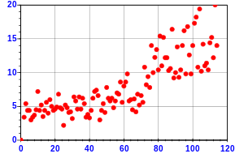 | 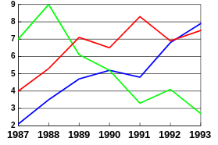 | 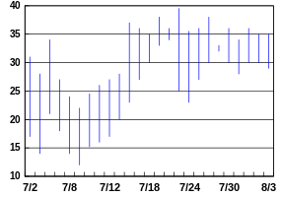
4 Bar | 5 Pie | 6 Histogram
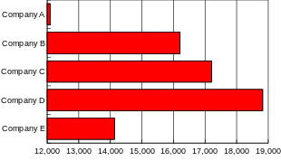 | 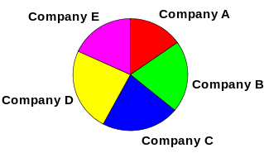 | 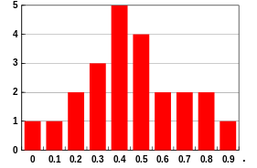
7 Area | 8 Bubble | 9 QC
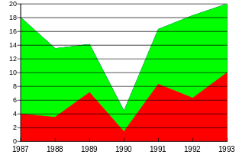 | 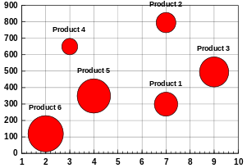 | 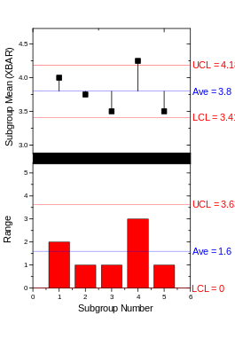
10 Polar | 11 Cluster | 12 Vector
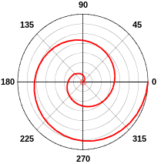 | 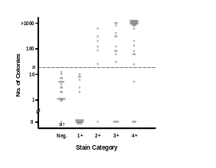 | 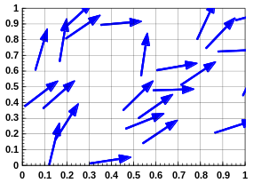
13 Mixed | 14 Organisation | 15 Text
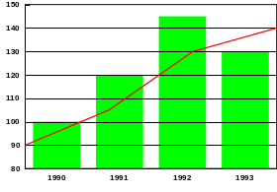 | 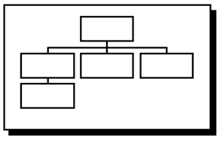 | 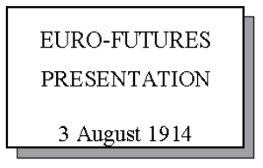
16 2D Contour | 17 3D Scatter | 18 3D Grid or Column
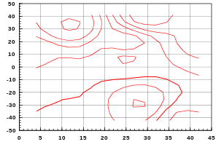 | 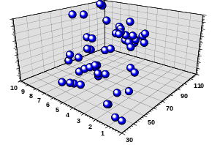 | 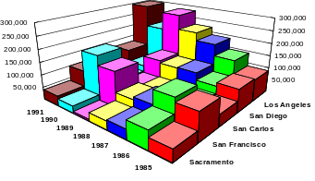
19 3D Histogram | 20 3D Surface | 21 4D Contour
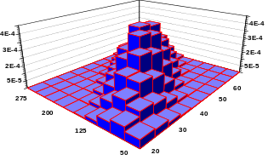 | 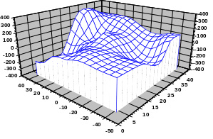 | 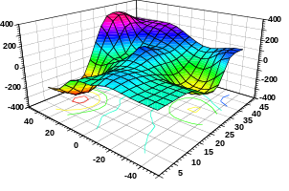
Figure 1: The Picture Gallery
The pictorial representation of the types of chart types shown in Figure 1 are now described in greater detail in the rest of this chapter.

2D CHARTS
3.1 Scatter charts
This is the classic 'X vs Y' chart - indeed, some packages call it just that. Ideally suited for continuous variables in X and Y, it usually requires that a line of best fit is drawn. Generally this will involve linear regression, but there might be cases when a spline or quadratic function will be required. Will the constants of the fitted curve or line be available, and can they be added to the chart?
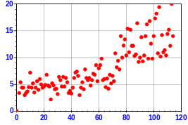

3.2 Line charts
The line chart is a favourite of scientific workers. With date variables, this sort of chart is particularly useful for showing seasonal variations. The line and scatter charts are related and have many similar features - the line being a form of scatter chart in which the data points are connected, but a data marker is rarely shown. In the scatter chart, it is assumed that X and Y are continuous variables, while the X-axis for a line chart may well be a discrete variable. It may be necessary to fit a curve or straight line through the data points, either to show a trend or to estimate a line of best-fit via regression to act as a standard curve. What level of complexity of curve-fitting will be required? Will statistics on the data (such as standard deviation, mean etc.) be required? Will correlation coefficients be required on lines?
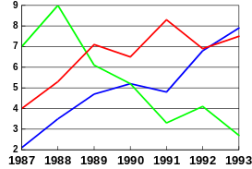
How many data series will be plotted? It is sensible to limit the amount of information contained in a chart, so that none of the information can be overlooked, and to avoid a cluttered presentation. Two simple charts are better than one over-complicated one. Six data series should be regarded as a maximum.

3.3 High-low charts
Stockbrokers and laboratory scientists both use charts which show an intermediate value between two extremes. This sort of presentation is extremely important in medical and scientific work. Many packages which are designed for business use have high-low-close facilities which can be adapted to showing error bars, however some use terminators to the bar which do not fit in with scientific practice
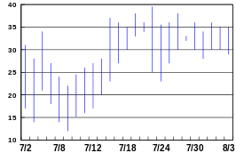

3.4 Bar/Column charts
Bar charts are displayed horizontally across the chart, column charts are displayed vertically. The true bar chart is not often seen, but can be an excellent choice when the categories require complex naming. The paired bar chart is very effective in displaying the differences and similarities in two variables.
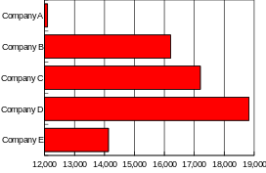
Stacked bars are useful in certain circumstances, particularly if there is a danger of cluttering the chart, but can prove difficult to interpret. Once again, the most effective chart is one in which the amount of information is understandable and which does not overwhelm the viewer or reader.

3.5 Pie charts
The Pie chart is most effective when displaying up to six variables, but these can be augmented with linked pies and columns. The exploded segment is useful for drawing attention to a particular segment, and can create striking visual effects. Many packages allow the data to be plotted as absolute values or as percentages of the total, and some have control over the orientation of the pie and the starting angle of the divisions. Multiple pie charts can be very effective.
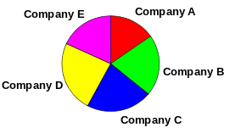

3.6 Histograms
Confusingly, column charts are often referred to as bar charts. However histograms are a specific class of column chart associated with statistical work that calculates and displays the distribution of data in adjacent single columns of values
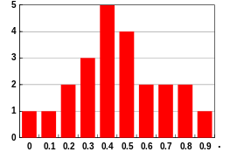

3.7 Area charts
On its own, the area chart is little used: Perhaps that should be encouraged! It can fit in well with other charts, however, to form a mixed chart when two Y axes are used.
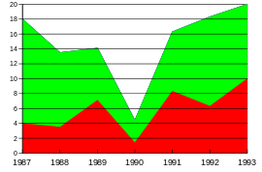

3.8 Bubble charts
The Bubble chart displays an X, Y location together with the relative size of each item. It is frequently used in market and product comparison studies
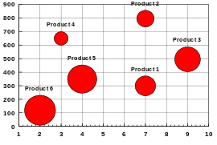

3.9 QC Charts
The quality control chart is highly specialised, but very widely used. CuSum (cumulative sum) techniques are in use in manufacturing and analytical facilities worldwide - yet they are virtually unknown outside the QC laboratory. Some disciplines have other techniques which are in daily use. The simple example on the left shows the differences occurring between sampling subgroups in a large production run. Many of the highly specialised techniques, such as V-masks, are beyond the scope of general-purpose packages, although those who require such facilities may find that the literature on their subject contains references to how standard packages have been adapted to fit these requirements.
?

3.10 Polar charts
A polar chart is one based on the polar coordinate system (as opposed to, for example, the Cartesian coordinate system). Each data point is defined in terms of a coordinate pair (r, theta); r is the distance from the centre of a circle (usually the origin of the polar graph), and theta is the relative angle from a specified reference vector based at the centre of the same circle and extending to the "3 o'clock position” on the circle.
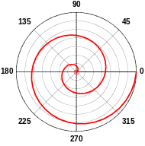

3.11 Cluster chart
The term 'cluster' has been coined especially for this document This form of data presentation is extremely common in certain disciplines. It defies many tenets of graph drawing, but it offers a useful visual method of imparting information. The most common application is the situation of low, normal and high values; for example, the levels of TSH in subjects whose levels of thyroxin are too high, too low or normal. This representation is common where the levels of an analyte are too low to be measured accurately, or too high for the exact concentration to be relevant and results are quoted as 'greater than some level'. Results are clustered together with the X-axis being descriptive rather than numeric.
?
This sort of chart is often seen in medical and biological work, but the facility is not offered by many packages. The requirement for this sort of presentation should always be discussed early in an analysis of requirements: it cuts down the choice of packages dramatically and can save a lot of time!

3.12 Vector chart
A vector chart is used to display the location, direction and magnitude of XY data pairs
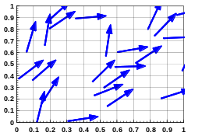

3.13 Mixed charts

There are times when it is sensible to represent one set of data in one-way and another set in a different way, especially when a second Y-axis is used. This feature has generally been difficult to find in the graphical parts of spreadsheets and should be investigated early in the analysis of requirements. It is an effective tool in the right circumstances, but should not be overused.
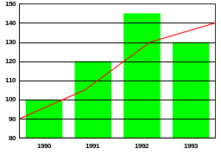

3.14 Organisation charts
Organisation charts are useful for displaying management structures. The number of levels required must always be defined.
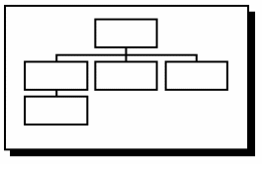

3.15 Text charts
The text chart is perhaps the most widely used chart of all. Important limitations may cover subscripts and superscripts, foreign characters, chemical symbols and mathematical symbols. The most basic word processor can generally be of some use, although an early definition of the requirements for coloured text, gradient-filled backgrounds, imported bitmaps etc. will ascertain whether a word processor or a sophisticated presentation package will be needed. There is now considerable overlap in the facilities offered by word-processing, desktop publishing and presentation packages; the deciding factor maybe one of the choice and availability of output devices, or it may depend simply on personal preference and familiarity. In any event, it is essential that the package has all the facilities required; some DTP packages, for example, have very poor drawing facilities, while some modern WP packages have quite sophisticated drawing facilities. For the purposes of this document, text is considered to be a special case of graphics data.
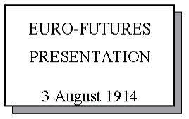

3.16 2D Contour charts
It is often necessary to be able to represent certain data as a2-dimensional surface in 3-dimensional space. In general, we wish to plot a function of the form z=f(x,y), where, typically, the x and y values represent the 2-D location of a point, and z represents the variable to be visualised. One method is to make use of contour lines, as in, for example, an Ordnance Survey contour map. In the case of a relief map, the altitude at points within the area represented by the map is the function concerned, and the grid reference coordinates of these points are the independent variables. Data visualised via contouring are typically measurements of the height of a particular landscape, but in fact, anything which is a function of two independent variables, and which can be measured in some sense, can be visualised via contouring.
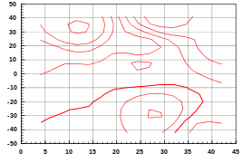

3D CHARTS
3.17 3D Scatter
Similar to 2D scatter charts, except that the addition of a third Z co-ordinate allows the data to be represented in 3 dimensional space.
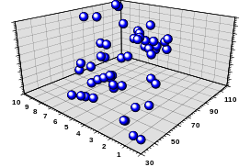

3.18 3D Grid or regular column chart
A grid chart is effectively a 3 dimensional column chart of regular data Many packages give support for converting irregularly space data to this regular grid form for analysis.
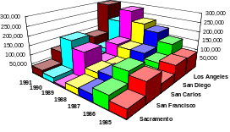

3.19 3D Histogram
Similar to 2D histogram except that it calculates and displays the distribution of X-Y pairs from two columns of data thereby giving a 3D distribution of data pairs. It may also be considered a special form of 3D grid.
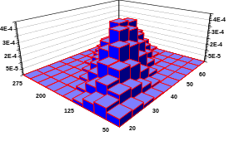

3.20 3D Surface charts
A 3D surface plot graphs a matrix of X,Y and Z values as a 3 dimensional; grid or mesh.
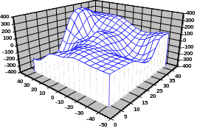

3.21 4D Contour charts
The is a combination of laying a contour plot over a 3D surface plot.
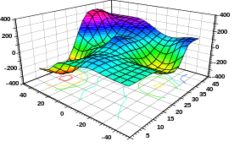

4 The Anatomy Of Charts and Drawings
(The Picture Gallery extended)
Figure 1 in Chapter 3 gave a pictorial representation of the types of chart. We shall look at the general features of each type and describe many of the terms used in the facilities matrix (see Appendix 2)
Next, we examine the details of charts and the terminology involved. The term ‘data series’ is used to describe a group of numbers or measurements which refer to one variable. Some packages limit the amount of data in any one series, while keeping the total amount of data constant; others set an upper limit on the number of data series while allowing each series to contain large amounts of data. These constraints are often very important in the choice of package appropriate to the analysis and presentation of the data. Always bear in mind that a chart can become overcrowded and unintelligible if there are too many data series, so some of these constraints may be beneficial.
Charts
We cannot cover every possible chart or pictorial representation as each discipline has its own specialities, but the facilities offered by packages continue to develop and expand. If a particular feature is not available today, check again in six months time - a new product may be available or the facilities offered by existing packages may have changed.

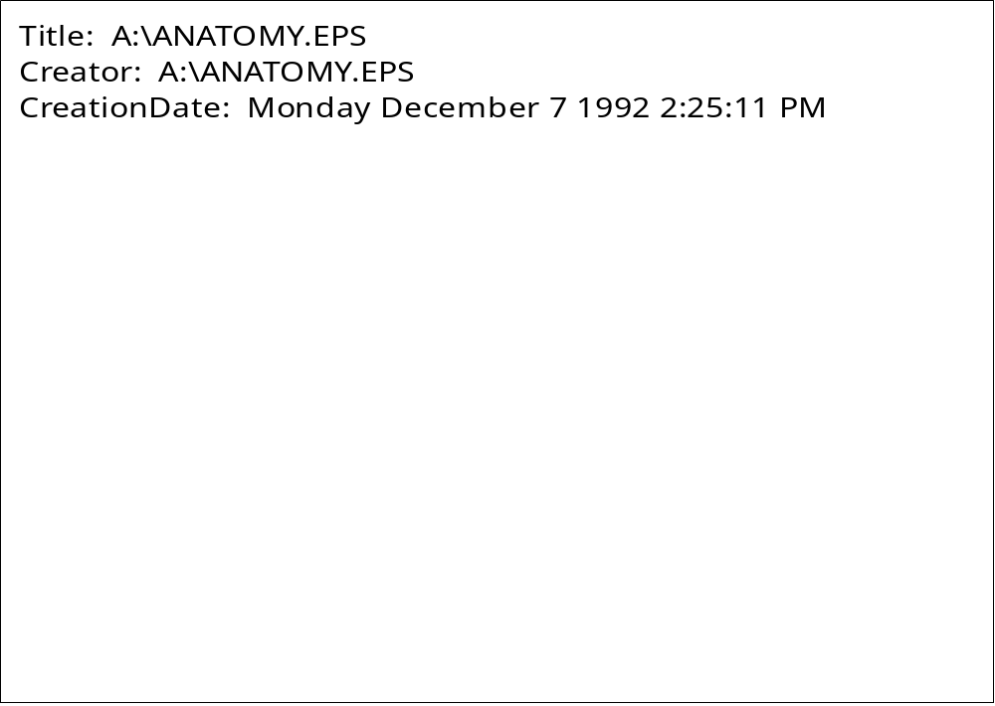
Figure 2: The anatomy of a chart

The title and subtitle, and perhaps the footnote, are common to many types of .chart. Sometimes they are identified specifically and sometimes they are added as separate text, not identified specially. The title and subtitle give the audience an important ‘handle’ on the message and draw attention to what is being said. Sometimes they emphasise the speaker’s identity or affiliation. The footnote is useful in organising charts.
The legend explains what each series of data represents. Different line types are required for black and white output, while different colours can be used to distinguish the different data series if colour output devices are available P but bear in mind that colour vision is impaired in a significant number of people, and also that certain colours do not stand out in poor lightning conditions. In some circumstances it can be valuable to give the exact value of a data point, while in others, overall trends are all that is required.
‘Missing data’ are always a problem. If a data series is likely to be incomplete, how does a package respond? Does it simply skip over the blank or does it interpret absence as zero? Can missing data be coded so that the package knows to skip over the value? Will the package expect a full data series for each variable in a group?
Many series of data contain outliers or extreme values which distort the presentation: will logarithmic axes be necessary? If so, how will the package represent a zero value? Can the axes be split to avoid large areas of empty space?

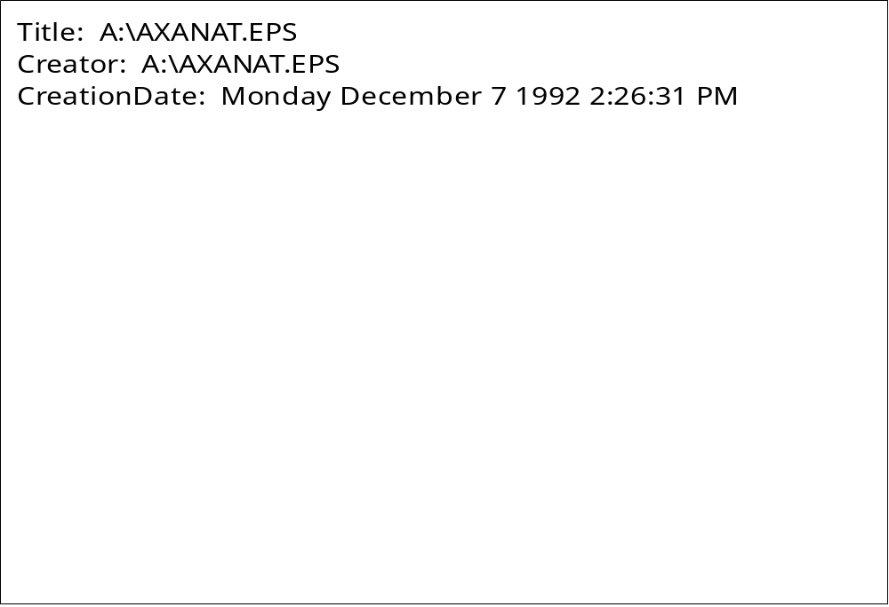
Figure 3: The anatomy of axes

Examination of papers in scientific journals will show that there is a wide variety of methods for presenting axes: does the target journal have a specific style? Will separated axes be necessary? How many major divisions are appropriate for the data and what is the best number to choose to enhance the message without cluttering the display? Can the maximum and minimum values for the axes be defined? Are subdivisions really necessary or will it be best to give exact data values? Will the placing of the axes’ tick marks be important?
What sort of X-data will be employed? Textual, numeric or date? If a time series is required, what is the best way to show the divisions? How will the axes be labelled? Will scientific notation, subscripts, superscripts and non-English characters be necessary? If so, can the printer produce the full range?
Is the orientation of the Y-axis label important? Can it be aligned vertically? How many X and Y axes are needed and how many are optimal to present the data, but to avoid over-crowding the image by presenting too much data? Will contours and Z axes be necessary?
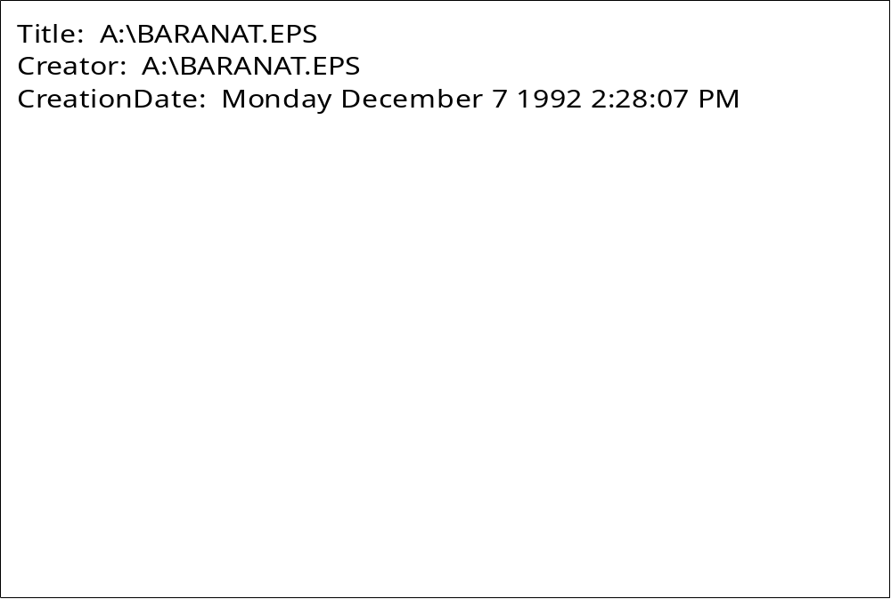
Figure 4: The anatomy of bar and column charts

The line or scatter graph is very widely used for presenting scientific data, while bar and column charts are often used for showing differences between discrete variables. Many of the ideas introduced here can be applied to other types of chart.
The width can be varied so that columns touch, as they do with histograms, or points can be emphasised by keeping the columns separate. The display can be made less cluttered by overlapping the columns or by stacking the data. Percentages can be emphasised by employing the stacked column (100%) technique and some pleasing results can be obtained by adding 3D effects. The combination of 3D effects and overlapping can, in certain circumstances, hide data if a tall column comes in front of a short column; in this case it may be possible to change the angle of vision by rotating the chart. If this proves necessary, is the choice of chart type appropriate?
The paired bar chart is often good at showing differences between two categories, such as the comparative performance of two cars over a number of criteria. The choice of fill pattern can also be important P solid colour can be easier to distinguish than similar patterns, particularly if there is unfortunate juxtaposition of small data sets.

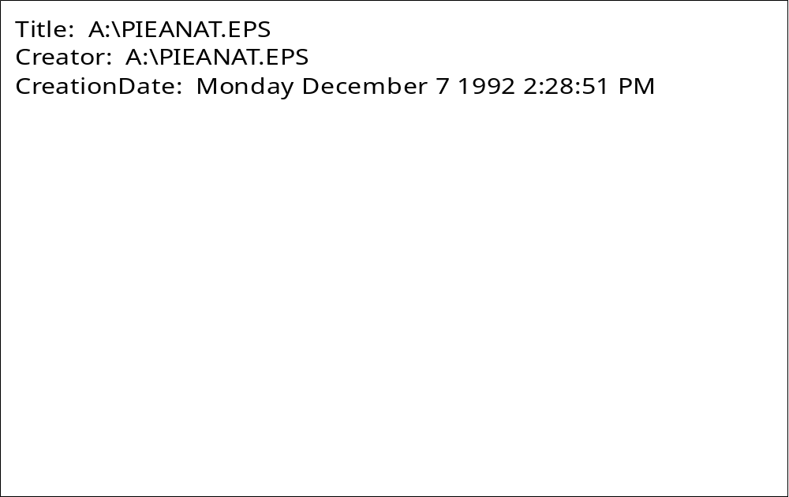
Figure 5: The anatomy of a pie chart

A Pie-chart is a popular and useful way of representing small numbers of variables. Particular aspects can be emphasised by exploding segments. Some packages are poor at exploding 3D pie charts. Will it be necessary to show data values, or percentages of the total? If there is an aggregated group (‘other’), will it be useful to have a linked pie or column chart giving a detailed analysis?
The pie chart is ideally suited to small numbers of variables, so the number of fill patterns or colours available will rarely be an issue, although the appropriate choice of pattern or colour will be important.

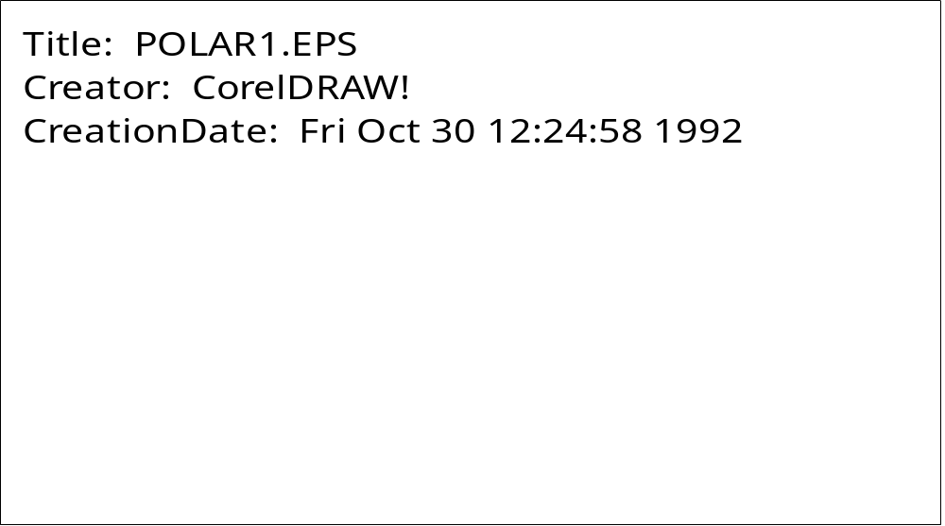
Figure 6: The anatomy of a Polar Chart

Polar charts are used in science and engineering in applications where it is more natural to express coordinates in polar than in cartesian form.
Drawings
Figures 7 and 8 show some of the tools a skilled artist can use for eye-catching effects. Rotation, skewing and mirroring are available in most drawing packages, but the power of control point adjustment, perspective adjustment and ‘enveloping’ are confined to specialist programs. In particular, control point adjustment gives incredible power over positioning and the shape of curves. These techniques can be combined with the ability to fill objects with different patterns and colours to create images which are attractive, as well as informative.

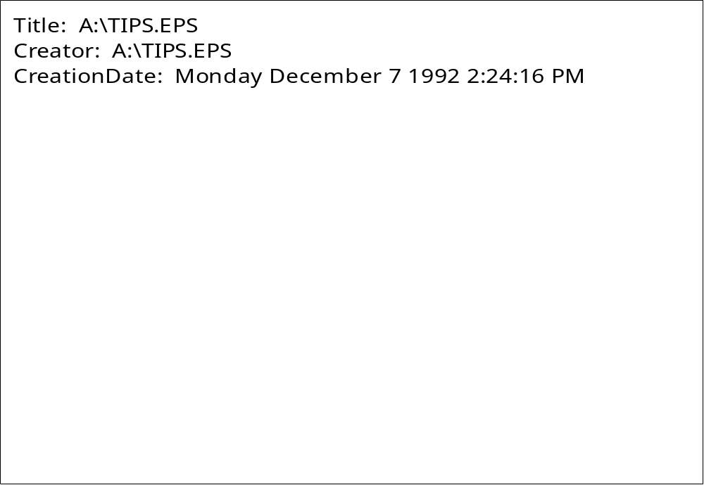
Figure 7: some features of freehand drawing

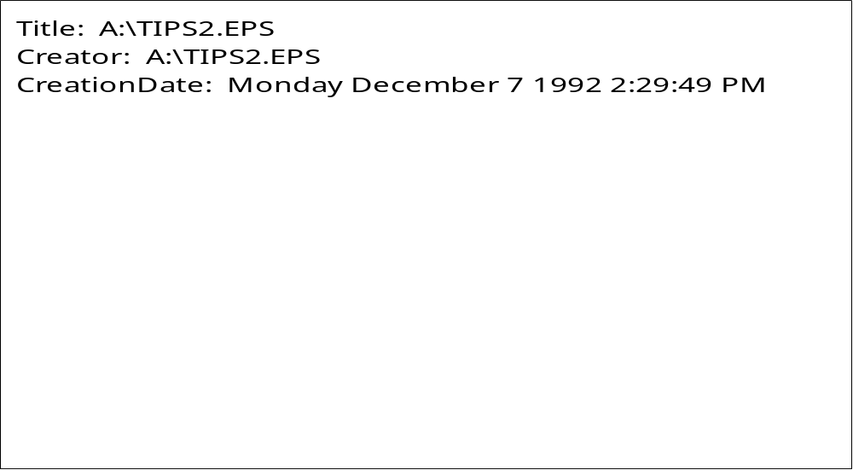
Figure 8: more features of freehand drawing

Aspects of Design

The issue of picture design is a potentially complex one which raises many questions, such as:
Typefaces What sort of font (bold, italic, etc.) should be used? how many different typefaces should be used within any one picture/ What size of typeface would look best?
Layout Where should the various components of a picture be placed in relation to one another? What relative size should each picture component be? What effects can be employed to draw attention to one particular aspect of a picture?
Colour Which colour combinations go well together? Which combinations should be avoided? which combinations should be used to compensate for colour blindness? Should colour be used at all? Would black and white (or some form of grey scale) be more effective in particular circumstances?
If users are uncertain about these or any other aspects of design, professional advise should be sought. Refer to the supplement for references to any such bodies within your organisation.
On the specific issue of colour in computer graphics, there are numerous publications. Some very useful introductory articles/booklets for anyone interested in learning more about colour usage are:
- Using Colour in Computer Graphics, F.R.A. Hopgood, published by the Advisory Group on Computer Graphics, Technical Report No 4, January 1991.
- Picture Perfect: Color Output for Computer Graphics, J. Rowell, published by Tektronix Inc, 1990.
- The Effective Use of Color, G. Murch, Tektronix Inc, Tekniques Newsletter, Vol 7 No 4, Winter 1983, Vol 8 No 1, Spring 1984, Vol 8 No 2, Summer 1984.
The specific topic of colour blindness, and how to produce pictures which compensate for it, is covered in:
- Computer Graphics: Principles and Practice, Foley, van Dam et al, Second edition, 1990, Addison-Wesley.
Local advice and access to reference documentation may be available locally - refer to the Supplement at the end of this document
5 Using Graphics Files and Images
When preparing a document there are a number of sources from which images may be obtained. You may produce them yourself using a Drawing or Charting package or you may obtain them ‘already drawn’ as Clipart. In either case the image will probably be stored at some point in a file.
If you produce them yourself you need only select a suitable exchange format which is common to the export/import facilities of the packages concerned. Alternatively it may be possible to bypass the file stage completely by the use of the ‘Cut and Paste’ facilities.
If you use Clipart, it usually supplied in the native image format used by that particular package. Often a package will also support other than it’s own native format, so a wide variety of clipart may be available to you.
Popular file formats
There are a large number of different formats for storing graphics information in files. this list below only enumerates some of the more popular ones that are supported by the leading software packages. For more information you are recommended to consult either Graphics File Formats by Davis C. Kay and John R. Levine (Windcrest/McGraw-Hill, 1992) or Encyclopedia of Graphics File Formats by (O’Reilly & Associates, 1994)

BMP (Windows Bitmaps)
This is ideal for exchanging bitmap data between Windows applications, but is not widely available outside Windows.
CGM (Computer Graphics Metafile)
The CGM is an ISO standard for capturing and transferring picture information. "Computer Graphics Metafile" This is the first official standard for graphics files and should be a reliable solution for the storage and exchange of graphics files - but it is large and unwieldy, and different implementations are not always mutually compatible.
GIF (Graphics Interchange Format)
Bitmap format developed by Compuserve. Good for cross-platform file exchange. Widely used, file compression means smaller storage requirements.
HPGL (Hewlett Packard Graphics Language)
A line based vector format originally developed for driving HP plotters, and available on some non pen plotter devices such as laser printers. It may also be used for transferring line-based information between applications
JPEG (Joint Photographic Experts Group)
JPEG is a standard format developed by the Joint Photographers Experts Group, allowing transfer of files between a wide variety of platforms, using superior compression techniques.
PICT (“QuickDraw Picture Format”)
This is a vector and bitmap page description language originating on the Mac. It is one of the commonest graphics standards on the Mac where it is very useful for exchanging both vector and bitmap data, but its colour support is limited, and it can only compress monochrome bitmap images. Versions of PICT are beginning to appear on PCs.
EPS (Encapsulated PostScript)
Postscript is a page description language for both vector and bitmap graphics, which has become a de facto standard (see section 6.1 on page 28). It was originally intended for driving output devices such as printers, but is now widely used for storing and exchanging graphics images - for which it should be used in its "encapsulated" form EPS ("raw" PostScript can disrupt a document if it is inserted into it, rather than being sent straight to a printer). PostScript produces very portable plain text files, but these can become large and unwieldy for bitmap images. It has become a standard for desktop publishing.
PCD (PhotoCD)
This is storage format developed by Kodak for the storage of bitmap images
PCX
Also known as PC Paintbrush, this is a bitmap format for desktop publishing, general graphics, and video. It is particularly useful for exchanging data between PCs. It is one of the oldest, and therefore most widely established, bitmap formats for PCs, supporting colour and large images, but some implementations may not be mutually compatible.
Sun Raster Files
These are bitmap format. Widely supported by Sun utilities and applications
TIFF (Tag Image File Format)
This is a bitmap format for exchanging data between desktop applications, and available on Macs, PCs and Unix workstations. It is widely available, flexible and well-supported, and is excellent for storage, but non-standard extensions to the basic TIFF format mean that exchanging graphics between different platforms can sometimes fail.
WMF (Windows Meta File)
WMF files are useful for storing and exchanging graphics images under the Windows operating system, producing small, well-structured, device-independent files. It supports both bitmap and vector format.
XWD (X-Windows Dump)
This is a bitmap format. It is a useful method of exchanging bitmap based graphics between most X-Windows applications.
Graphics Metafiles
A Graphics Metafile is a file which contains a description of a picture (or set of pictures) expressed in some well-defined, formal manner. Graphics metafiles help to provide device independence by allowing pictures to be printed on a variety of devices; metafiles also facilitate picture portability by enabling the image(s) to be transferred to wherever they are required
The ISO standard metafile is the ‘Computer Graphics Metafile’ (CGM). There are also proprietary standards such as the Microsoft Windows MetaFile (WMF) and the Macintosh PICT file - these are particularly useful for transferring images between applications in the same operating system, although it is often possible to use, say a PICT, file in a Windows environment. CGM, where supported, allow transfers of information between all systems.
Apart from the above three graphics metafiles, there are numerous other graphics file formats in use, particularly on microcomputer software. These other graphics file formats tend to be used both for the compression of picture data and for the interchange of picture information between software packages. What usually happens is that the package exports the picture in a particular format which is then imported in that format by another package. The list of file formats available is extensive: the commonest are summarised in chapter 5. Additionally the matrix in Appendix 2 shows which files are interchangeable between chosen packages via the import/export mechanism.
Clip Art
The term ‘clip-art’ applies generally to any collection of computer-based images or symbols which can be readily incorporated within a user’s picture. Most popular presentation graphics packages now include clip-art libraries covering a wide range of subjects. The idea is that the user’s picture can be enhanced by the judicious use of particular images. For example, a chart which shows motor car production in the UK may be improved by including an image of a motor car. A clip-art library will typically contain a set of images of everyday objects such as space rockets, telephones, washing machines, houses, furniture, airplanes, books, thermometers, ... indeed just about most things imaginable. Exactly how clip-art images are included within a user picture varies from package to package, but it is usually a straightforward process, and - again depending on the package - it is usually possible to expand, shrink or rotate the clip-art symbol so that it can be integrated within the picture to suit the user’s requirements.
Note! Users should take care that they do not inadvertently infringe copyright restrictions by including images within their pictures, such as for example company trademarks or logos, which may require copyright permission.

7 Explanatory Notes On Facilities Matrix
GENERAL INFORMATION MATRIX
This section of the Matrix tells you about any facilities in the packages which are normally common to all types of presentation graphics packages
GENERAL
Licence Arrangements
Indicates any special deals by which you can obtain a package at less than the full commercial cost.
Possible entries are -
- 'CHEST discount' for a UK-wide education price;
- 'CHEST site licence' for site licences negotiated by CHEST;
- ‘Select deal’ for software available under the Microsoft Select scheme.
- 'Academic discount' for reduced prices, usually due to some special arrangement;
- 'No' for no special deal.
Package Description
Description gives a very brief summary of what a package is, to give you a quick idea of its intended application area.
Entries in Creative Graphics Matrix
Entry is ‘Yes’ if there is further information in the ‘Creative graphics matrix’ section, otherwise ’No’.
Entries in Data Driven Graphics Matrix
Entry is ‘Yes’ if there is further information in the ‘Data Driven graphics matrix’ section otherwise ’No’.
SYSTEM ENVIRONMENT
Platform
This entry tells you what sort of machine you need in order to run a package.
Platform indicates the hardware, and operating system if relevant - for example Windows', 'Mac', 'Unix'.
Web Site of interest
Web site URL’s of interest. These may be the application vendor or possibly a user group page. Blank if no site exists.
Special requirements
Indicates any special facilities you need in order to get the most out of the package. If extra clipart for instance is supplied on CD, enter ‘CD’ here.
Scripting language Available
Usually ‘Yes’ or ‘No’. Many packages support some form of scripting language to allow extensions to the functionality of the application.
USER ENVIRONMENT
User interface
This entry tells you about the general overall appearance of each package.
User interface is usually ‘WIMP’ on PCs and Macs - for “Windows Icons Menus and Pointer”. In this case you can control programs by pointing and clicking with a mouse, and manipulating windows and icons on your computer screen. The main alternatives are menu-based programs - driven by a mouse or the keyboard, and command-driven programs.
On-line help
Can be ‘Yes’ if there is any help information within a package, or ‘No’. If ‘Yes’, the help available is often enough to let you run the package without extensive documentation.
OLE support
Package supports Object Linking and Embedding for MS Windows. This allows graphics objects created by one piece of software to be embedded in a graphical object created by another but still maintain it’s link with the original software - i.e. any changes made to the object will start up the original package and allow you to edit the original object .
FONTS
Extra Fonts supplied with package
Most packages simply use the fonts which are available on their host computer, though some provide extra ones. The type of extra fonts which are available with the package are shown here, i.e. ‘Truetype’. (See the entry for typeface in the glossary for a definition of the terms 'font' and 'typeface' as used in the matrix.)
Number
Number of fonts supplied.
IMPORT/EXPORT GRAPHICS FILE FORMATS
A great many different formats are used for graphics files, which have evolved over the years. The term "file format" refers to the way in which a graphic is stored in a computer file. Different programs use different formats to store the files they create.
These entries show you the main ones which each package can import (cope with) or export (produce). The entries here should enable you to determine whether you can swap graphical images between two or more of the packages you want to use.
The section ‘Using Graphics Files and Images’ gives more details on this subject. For extra information, you are recommended to consult Graphics File Formats by David C. Kay and John R. Levine, Windcrest/McGraw-Hill, 1992.
It is sometimes adequate to use cut-and-paste for transferring graphics images between applications on a single machine: this saves you the trouble of choosing a graphics file format for the exchange. OLE is another method by which graphics objects may be embedded in a presentation.
File Type abbreviations
AI | Adobe Illustrator | PCT | MAC PICT
BMP | Windows | PCX | CorelPHOTO-PAINT
CDR | CorelDRAW | PFB | Adobe Type 1 Font
CGM | Computer Graphics Metafile | PIC | Lotus PIC
DRW | Micrographx Draw | SCD | Matrix/Imapro SCODL
DXF | AutoCAD DXF | SUN | Sun raster file
EPS | Encapsulated PostScript | TGA | TARGA Bitmaps
GEM | GEM Files | TIFF | TIFF Bitmaps
GIF | Compuserve Bitmaps | TTF | TrueType Fonts
HPGL | HP Plotter language | WMF | Windows Metafile
JPEG | JPEG Bitmaps | WPG | WordPerfect Graphic
PCD | Kodak Photo-CD | XWD | X-windows dump
OTHER FEATURES
Slide show facilities
Is ‘Yes’ if the package can show a sequence of images, either under control or unattended, to support a talk or as an unattended demonstration.
Templates/Style sheets
Is ‘Yes’ if you can store general attributes without specific data, to act as templates for future productions; otherwise ‘No’.
Clip Art Supplied
Is ‘Yes’ if the package includes a library of graphics images for inclusion in your charts, otherwise ‘No’.
Automatic backup facilities
Is ‘Yes’ if you can tell the package to save your work every so often, or ‘No’ if you have to remember to save it yourself.
Pantone matching
Is ‘Yes’ if the package supports the internationally recognised Pantone system of specifying colours, otherwise ‘No’. This feature is particularly important if you need to get the best output from bureaux.
Extra Drivers with package
Most Windows and Macintosh packages rely on their host system to deal with printers etc. Any extra facilities provided by individual packages are listed in this section, an example of this might be a 35mm type driver.
DATA DRIVEN GRAPHICS FACILITIES MATRIX
DATA HANDLING FACILITIES
This section of the Matrix tells you about any facilities in the packages which can help you prepare your data for graphical display.
Editing facilities
Either ‘Yes’ or ‘No’ - indicates whether or not you can edit your data within a package before display.
Calculation facilities
Can be ‘No’, 'simple' (meaning that you can do simple transformations of data), or 'complex' (if you can carry out complex calculations on the data before displaying it - calculations such as those which you can perform in spreadsheets).
Graph and data directly linked
Tells you if a change to the data or alteration of the graph is automatically represented by an update of the other (i.e. the data or the graphical display)
Statistical analysis
Is either ‘Yes’ or ‘No’, to indicate whether a package can calculate statistical information about your data - such as mean and standard deviation.
Maximum number of variables
Indicates the number of variables the package can handle.
Maximum number of data points
Indicates the number of data points for each variable that the package can handle.
Are missing values handled
Indicates what the package does with missing values in your data. Packages with statistical capability tend to do something sensible with such cases, while other packages might ignore them or substitute a special value.
Data Interpolation
Indicates that data interpolation methods are available in the package. These vary and only a general indication is given, reference to the documentation should be made for more specific details.
The cell entries may be ‘No’, ‘2D’, ‘3D’, ’2D+3D’.
2D indicates support for 2D data. - i.e. parametric interpolation etc., similarly 3D indicates support for 3D data - i.e. irregular data converted to regular grid etc.
2-DIMENSIONAL DATA DISPLAY
See CHAPTER 3 - ‘TYPES of CHART’
3-DIMENSIONAL DATA DISPLAY
See CHAPTER 3 - ‘TYPES of CHART’
OTHER DISPLAY OPTIONS
Error-bars (X or Y)
Indicates if error bars supported - applies to line charts. Entries may be ‘No’, ‘X-axis’, ‘Y-axis’, ‘Both’. Sometimes error-bars are also applied to other types of graphs, in such cases an entry (R) will appear in the ‘Graph Type’ cell., i.e. a bar/column chart supporting error-bars would have an (R) entry.
Curve fitting
Shows there are curve fitting options. These vary and only an indication ‘Yes’ or ‘No’ is given, reference to the documentation should be made for more specific details.
Plot Maths functions
Indicates if maths functions be plotted directly, for example from an equation. Entry is ‘Yes’ or ‘No’
View Point adjustment
Indicates that adjustment of the viewing position for 3-D graphical objects supported. Entry is ‘Yes’ or ‘No’
Read Data points
If the value of data points can be displayed by clicking at a position on the graph, entry is ‘Yes’ otherwise ‘No’
CHART AXES
This section of the Matrix deals with the appearance of axes in graph-type graphics. These explanations may be clearer if you refer back to Figure 3 in chapter 4: The anatomy of axes.
Axis
The Axis topics refer to the actual line which makes up the axis, and the positioning of axes.
- Change width/colour
Can be ‘Both’ if both options are allowed, ‘No’ if neither of them, or the specific name if only one is available.
- Allow Broken or Separated Axes
Can be ‘Both’ if both options are allowed, ‘No’ if neither of them, or the specific name if only one is available. A 'broken' axis has a section missing, for example to allow both ends of an extreme range of values to appear on a graph of manageable size. If axes can be separated, they can be positioned independently in the diagram - for example so they are set back from the data and do not meet at all.
- Axis scaling user-defined
Is either ‘Yes’ if the user can choose the range of values to be represented along the axis, otherwise ‘No’ if the package forces the scaling.
- Dual X/Y axes
Is either ‘No’, the name of the dual axis - (i.e. Dual X or Dual Y), or ‘Both’
- Logarithmic axes
Is ‘Yes’ if the package can produce logarithmic axes, otherwise ‘No’.
- Transposition of axes
Is ‘Yes’ if the X and Y axes can be swapped over, otherwise ‘No’.
Axis labelling
The Axis labelling topics refer to the various text items with which you can embellish an axis.
- Allow edit of axis titles
Is either ‘Yes’ if you can, or ‘No’.
- Position/move axis titles
Is ‘Yes’ if the package allows you to influence the positioning of the axis titles, or ‘No’.
- Orientation of Axis titles
Refers chiefly to the Y-axis title, which can be either 'horizontal' or 'vertical'. 'either' means that the package allows you to set the orientation of the title.
- Scientific notation, Sub/Superscripts
Is either ‘Yes’ if the package can cope with these in the axis title, or ‘No’.
- Foreign character support
Is ‘Yes’, ‘No’ or 'limited', depending on how easily the package will allow you to use foreign (for example accented) characters in axis titles. Refer to manual for more details.
Tick Marks
The Tick mark topics concern the appearance and labelling of the tick marks along the axis.
- Specify position
Is ‘Yes’ if you can choose to have ticks inside, outside or across the axis (or indeed to have no tick marks), or ‘No’ if the package doesn’t give you the option.
-Format options
For tick mark labels is ‘Yes’ if the package lets you choose the style of the tick mark labels (such as scientific, exponential, integer etc), otherwise ‘No’.
- Allow labelling only every Nth tickmark
Is ‘Yes’ if the package lets you choose which tick marks to label, otherwise ‘No’.
- Grid lines on chart
Is ‘Yes’ if you can choose to have tick marks running right across the chart, otherwise ‘No’.
OTHER CHART FACILITIES
This section of the Matrix covers floating text of any sort.
Titles
Is ‘Yes’ if the package lets you add a title, otherwise ’No’.
Legends
Is ‘Yes’ if you can add text anywhere on the chart, for example to act as a key, otherwise ‘No’.
Data Point labels
Is ‘Yes’ if you can label individual points in the graph, 'yes, some' if you have some scope for labelling points, otherwise ‘No’.
Floating labels (annotation)
Is ‘Yes’ if you can add general annotation to the chart, otherwise ‘No’.
Chart size/position adjustment
Is ‘Yes’ if the package allows you to adjust the size of the chart, otherwise ‘No’. It is useful if you can do this: while it won't make any difference to what you see on the screen, you get the best quality when adding a graphic to a printed document if you get its size right in the graphics package, rather than having to adjust its size in the printed document.
Background composition facilities
Gives you an idea of what backgrounds you can add to your chart. The main choices are 'coloured' (a plain coloured background), 'bitmap' (meaning that you can import a picture, logo or other graphic to have as a chart background), 'pattern' (to have the package generate a background pattern), or 'graduated' (for a variably-shaded background). The presence of a background facility in a package doesn't tell you if it is 'easy' or 'difficult', just 'possible'.
Frame/bounding box
Is ‘Yes’ if the package allows you to put a frame around the chart, otherwise ‘No’.
Multiple charts on page
Is ‘Yes’ if the package lets you create and group several charts on a single page, otherwise ‘No’.
CHART OBJECT ATTRIBUTES
This section of the Matrix covers the available attributes of items on the chart, or non-specific items which can be added to a chart.
Number of line styles & widths
The range of styles and widths are indicated by a general indication :-
1 no choice
<5 limited to five or less choices
5+ more than 5, reasonably unlimited
If the package allows the user to produce a customised linestyle or variable width a (u) is added after the entry.
Number of symbol styles
Shows you how many different symbols a package can use in a chart. The range is :-
1 no choice
<5 limited to five or less choices
5+ more than 5, reasonably unlimited
If the package allows the user to produce a customised symbol or change the size of an existing symbol a (u) is added after the entry.
Number of fill styles
Tells you the sort of fill styles which the package supports, for example to fill an area such as the segment of a pie chart or the area under a line graph. The range is :-
C Coloured Solid fill
G Graduated fill
P Pattern or Hatch fill
B Bitmap texturing
M Column/Bar type graphs may be substituted by Symbols
If the package allows the user to produce a customised fill pattern a (u) is added after the entry.
Size of pre-defined colour palette
Gives you an idea of how many different colours are pre-defined in package. Colour range is more important in Creative graphics, a large range of simultaneously available colours is necessary to create realistic effects. The actual range of colours may be limited by the Graphics Card, in which cases dithering may be used.
Additionally the user may be allowed to specify their own colour choice from a palette. In such cases a (u) is added after the entry. This will almost always be the case for Creative Graphics facilities.

GLOSSARY
3D | 'Three-dimensional' - a term used to describe attempts to draw a three- dimensional object such as a curved surface or xyz graph on a two- dimensional screen or piece of paper. Also called 'two-and-a-half dimensional'.
4D | 'Four-dimensional' - a 3D diagram in which colour is used to depict the variation of a fourth variable.
A0/A1/A2/A3/A4/A5 | Standard paper sizes: A4 is 297mm by 210 mm; A3 is 420mm by 297mm with sizes A2, Al and A0 progressively doubling. A5 is 210mm by 148mm
area chart | A chart in which the area of interest is shaded in solid colour: useful for capturing attention but should be used sparingly for best effect.
ASCII | The American Standard Code for Information Interchange - a standard for the representation of textual characters held in a computer system. For example the ASCII value for 'A' is 65, or 01000001 in binary.
bar chart | A 'horizontal histogram', in which data values are represented by horizontal bars. Not used widely, but particularly effective where each individual data point has to be named. See also column chart.
bramble chart | See cluster chart.
business graphics | A general term for methods of presenting data in a formal, structured fashion - such as a line graph, bar chart, pie chart or histogram. See also "creative graphics".
Cartesian coordinates | A measurement system for defining the position of a point with respect to two (or more) straight axes at right angles to each other. This is the commonest coordinate system, the main alternative being polar coordinates
CGM | 'Computer Graphics Metafile', an ISO standard by which pictorial information can be stored in a computer file, in which form it can be transferred and reconstituted. CGM is more commonly used for transferring graphical images between software packages than for sending it to output devices such as plotters.
chart | A general term indicating any drawing, graph, image, text, or combination of these elements.
CHEST | Combined Higher Education Software Team. CHEST arranges and administers software deals on behalf of the UK academic community. The CHEST Software Directory is available on-line through the NISS Gateway, and in book form.
clip art | Collections of graphic images or symbols stored in computer form which can be readily incorporated into more complex diagrams, documents or presentations to enliven their appearance. Clip art libraries are available to cover most everyday items and many specialised ones. Care should be taken to observe any copyright restrictions when using clip art.
cluster chart | A form of chart suitable for depicting data which only falls into a few restricted categories, such as 'normal', 'high' or 'low'. The x axis is then usually descriptive rather than numeric. Used particularly in medical and biological work.
column chart | A chart in which data values are represented by vertical columns: histograms are a specific class of column chart used in statistical work. See also bar chart.
contour chart | A method for depicting 3D data such as the heights of a landscape, or in general, for any measurements which are a function of two other, independent, variables. Thus each point is specified by three measurements, two for its position (x,y) and one for its actual value (z). An Ordnance Survey map is a contour chart.
creative graphics | A general term for informal and unstructured graphical presentation, not usually representing any pre-existing data. Common examples are drawings and diagrams produced by hand. See also "business graphics".
curve-fitting | The attempt to find a pattern in data by drawing a line through a set of points so that it goes as close as possible to all of them. This could be a straight line but is more generally a curved one, ideally with an underlying equation which would help to analyse the data.
DDE | See "Dynamic Data Exchange".
device driver | A software module which accepts input in some general form and converts it into specific instructions which are sent to a specific printer, plotter or other output device. For example many graphics packages and word-processors generate their output in device-independent form and rely on specific device drivers to produce the actual output. In this method of working every device must have its own specific device driver.
device independence | The operational mode of many graphics and word-processing packages, which do not produce their output in a form which can be sent to any output device (such as a plotter or printer), but which contains all the necessary information from which a device driver can generate the required output on information from which a device driver can generate the required output on a particular device.
digitiser | A device which converts graphical input into a digital form which can be manipulated in a computer. It consists of a tablet on which a diagram can be mounted, and a pen-like stylus which can be traced around the diagram,  Producing digital measurements which are fed into the computer.
digitising tablet | A graphical device which enables pictorial information to be input to a computer. It is especially appropriate for line-based pictures (for example mapping boundaries). The process involves drawing over each line with a special stylus or mouse device.
dithering | The technique of manipulating patterns of dots produced by a printer to generate more colours or shades of grey than it should be capable of. For example if a black-and-white printer can print a small box as a pattern of black and white dots, the overall appearance of the box will be grey, its precise shade depending on the relative proportions of the black and white dots. Similarly a simple colour ink jet printer can produce various shades of orange from patterns of red and yellow dots. This is a very effective technique, but the penalty is loss of resolution in the final image.
dot-matrix printer | A (cheap, noisy and comparatively slow) printing device in which text and graphics are produced by an array of pins forcing a printer ribbon against paper. The alternative is a 'non-impact printer' such as an 'inkjet printer' (relatively cheap) or 'laser printer' (relatively expensive).
dots per inch | ('Dpi') a measure of the resolution of an output device such as a computer screen or laser printer, which effectively shows the size of the dots it uses to generate characters and graphics. The bigger this number, the smaller the dots and the finer the resolution. For example, apple mac screens have 72 dpi, and most laser printers have 300 dpi, with 600 dpi starting to appear in desktop machines. The very best publications require at least 1200 dpi devices.
dpi | Acronym for dots per inch.
Dynamic Data Exchange | A proprietary method of linking the data in one application to a graphical or other display in another application. When the data is changed in the first program, the display in the second is updated automatically, allowing a single master set of data to be used for all purposes.
enveloping | "Envelope-ing" - distorting a graphical image by fitting it into a non- rectilinear shape, or envelope.
error bars | Lines which are added to the data points in certain types of graph to indicate the margin of error in that point - that is, the range within which it lies. An error bar indicates the range of values when several measurements are used to generate a single point on a graph, or the maximum possible error in measuring or calculating the position of the point.
font | See ‘typeface'.
functionality | A measure of the capability of, or range of facilities available in, an item of software or hardware. Modern computer packages and equipment tend to have much better functionality than older ones, and expensive ones greater functionality than cheaper ones.
Graphical User Interface | A characteristic style of user-program interface in which the computer is controlled graphically - by a mouse acting through windows and icons - rather than by issuing it with textual commands. See also WIMP.
grey scale | The ability of a black-and-white printer or screen to display shades of grey.
GUI | Graphical User Interface, pronounced "gooey". See also WIMP.
hardcopy | Output on a permanent medium such as paper, transparency, film or video, as opposed to temporary output to a computer screen.
histogram | A special form of 'column chart', particularly used in statistical applications, using vertical columns to display the value of the data point or the average value of a range of data points in a limited set of classes.
hot link | A connection between data in one program and its use in another, for example allowing data to be changed in a spreadsheet, whereupon a separate graphics or DTP package - connected to the first by a hot link - automatically changes its representation of that data.
HPGL | 'Hewlett-Packard Graphics Language' - a de facto standard language with which to control pen plotters, which is also accepted by a number of non- pen devices such as laser printers and electrostatic plotters.
image | ( 1) any graphic item, made up of any graphical elements including text. (2) a precise copy of the contents of a computer's memory, elsewhere in memory or on a disk.
impact devices | Printing devices in which text and graphics are produced by an array of pins forcing a printer ribbon against paper. They tend to be cheap, but produce low-quality output and are noisy and comparatively slow.
inkjet printer | Drops of ink at the paper, typically on a 300 dpi matrix. Results are almost as good as a cheap laser printer's, though the ink tends to spread a little, and will run if it gets wet.
Laser printer | A non-impact printing device which operates in similar fashion to a photocopier, in which a laser draws the image of a page on a photosensitive drum which then attracts toner on to the paper, where it is subsequently bonded by heating. Now the most popular type of printer for reasonable
LED printer | Very similar to a laser printer, but using leds (light-emitting diodes) rather than a laser to create the electrostatic charge on the drum.
Line art | A diagram which consists only of lines and text, requiring no complex grey level or colour shading.
Line chart | One of the commonest forms of graph, particularly favoured by scientists, with data points displayed against X and Y axes and all the points connected with a single line. The points themselves need not be shown. Alternatively, all the data points may be shown and a line drawn which doesn't necessarily go through them all but which gives a reasonable 'best fit' to them all.
media | Plural of 'medium', referring to the types of material on which computer output can be stored. The commonest media are disks (hard and floppy), magnetic tape (reel and cartridge), optical disks, punched paper and punched cards, ordinary paper, photographic film, video, and semiconductor 'flash-cards'.
metafile | A file which contains a description of a picture or set of pictures in a well- defined, formal manner. This allows diagrams to be transferred between different graphics packages, and also allows programs to ignore the specific details of particular output hardware - but just use a common 'device- driver' to translate the metafile into printer-specific instructions.
mirroring | Transforming a graphical image into its horizontally reversed form, as though reflected in a mirror.
mono(chrome) | An output device which can only show one colour, though possibly in several shades. Monochrome printers and some screens tend to be black- and-white.
non-impact devices | Printers and plotters which do not use physical force to transfer ink to paper, common examples being inkjet, thermal-wax and laser printers.
paired bar chart | A special kind of 'bar chart' which uses horizontal columns in pairs to emphasise the differences in measurements taken at two different times, places, experiments etc.
pen plotter | A reasonably cheap type of output device which uses pens to draw graphic images on paper. It is fine for producing smooth lines and is therefore the natural way to draw line charts, but it has few colours, is not sensible for area fill, and is slow for complex drawings.
perspective | A technique for making three-dimensional objects look more natural when represented on paper or screen, by for example making distant objects smaller than closer ones, and parallel lines converge in the distance.
pie chart | An effective method of displaying (preferably no more than) about six variables, rather like looking down on a circular apple pie which has been cut into slices. The size of each slice reflects the size of each variable.
polar chart | A chart on which data points are plotted in polar coordinates rather than 'Cartesian coordinates'. Each point is defined in terms of its distance from the centre of a circle and the angle a notional connecting line makes to the horizontal.
PostScript | A de facto standard page-description language from the Adobe Corporation, which is now the most widely used way of sending text and graphics to printers such as laser printers - many of which now have postscript interpreters built-in for speed and flexibility.
prepress | Final preparation of material to be printed to the highest standards, probably by an external, professional printer. This includes the specification of all the fonts and graphics used in a document.
presentation | In the normal sense of the word, a presentation is some kind of talk to an audience, possibly enhanced with visual or audio material. A 'presentation package' runs on a computer to assist with the production of illustrative material to be used in a presentation, either in generating such aids as overhead or 35mm transparencies, or - increasingly - used at the presentation itself, with the on-screen images viewed directly by the audience.
QC chart  Quality control chart | A chart which shows the acceptable range of measurements, perhaps on some manufactured item or experimental data, on which actual measurements can be plotted to show whether the manufacture or experiment is proceeding satisfactorily.
raster | The technique of building up a graphical image as a series of on/off or coloured dots along a set of lines on a screen or other output device. A television set is the commonest form of raster device. In a laser printer or computer display, for example, the image is built up by a signal which is swept along each line in succession, and variously attenuated to produce the required pattern. The alternative method of producing images is 'vector'.
resolution | The fineness of detail which a computer device can detect or produce. For example a high-resolution screen or printer can show fine detail, and a high- resolution scanner or digitiser can detect fine detail.
rotation | Transforming a graphical image by rotating it about some axis, to some degree. 'Mirroring' is a special case of rotation.
scanner | A device which scans a light across a page of text or graphics and feeds a digitised representation of the image into a computer for storage or further processing. Scanners are typically flat-bed (like a photocopier), rotating- drum, or hand-held. If the image is text, there are software packages which can convert it from an image to actual characters which can for example be loaded into a word-processor.
scatter chart | A classic 'x vs y' graph consisting of two axes, with each data point marked with its own symbol: like a 'line chart' but without the connecting lines.
site licence | An agreement between a software publisher and an educational establishment which allows software to be acquired at a reduced price, on condition that it is only used for academic, non-commercial purposes.
skewing | Transforming a graphical image by distorting it about some axis, to some degree. For example, a square can be skewed into a diamond shape.
subscript | Text which is written on a lower baseline, and usually in a smaller font, than its surrounding text, as for example the x in lx.
superscript | Text which is written on a higher baseline, and usually in a smaller font, than its surrounding text, as for example the 2 in x2.
text chart | A chart consisting mainly or exclusively of text, added graphical elements including colour, font and background. Text charts are commonly used on overhead and 35mm transparencies and in 'presentation' packages, for example.
typeface | A character design, specifying the shape of all the upper and lower case characters, numerals and punctuation symbols. Different typefaces are useful in different contexts, for example in running text or in headlines, and to give an old-fashioned, or conservative, or modem, or striking appearance. Commonly used typefaces include times, helvetica and courier. Each typeface is actually a family of individual 'fonts', each of which represent the typeface in a particular size (such as 12 point) and style (such as bold or italic). The words 'font' and 'typeface' are increasingly - and inaccurately - used interchangeably.
Uniras | A large and powerful graphics package available on a range of computer platforms to enable users to generate most types of graphical output
vector | A straight line drawn from one point to another point. Vector devices, of which the commonest type is the 'pen plotter', are designed specifically to draw or plot vectors, making them ideal for graphical objects such as line charts which consist only of lines. The more versatile alternative is a 'raster' device.
WIMP | "Windows, Icons, Menus and Pointer", or "Windows, Icons, Mouse and Pull-down menus" This is a graphical interface which makes access to computers much more straightforward and intuitive than the main alternative, the command-line interface. The WIMP interface has been used on Apple Macintosh computers since they were invented, and are coming into use on PCs through Microsoft Windows and on Unix and other workstations through the X Window system.
Windowing System | A graphical (GUI) interface to a computer's Operating System, giving the user such features as windows, a mouse and pull-down menus by which to drive the computer, rather than having to type in command words.
workstation | Any computer which can sit on a desk, though usually taken to indicate amore powerful machine such as those from Sun or Silicon Graphics, rather than a less powerful PC or Apple Mac.
WYSIWYG | "What You See Is What You Get" - the description of systems or packages which faithfully represent on the screen what a document will look like when printed.

